**TICKETBOOKING SYSTEM TASK OUTPUT**

**Task-1 Conditional Statement:**

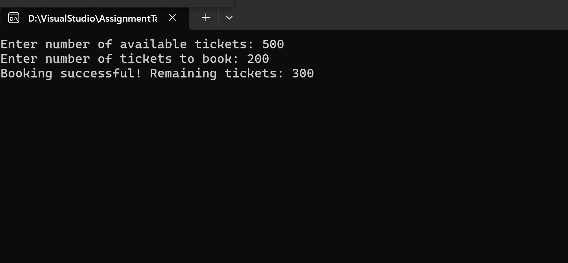

**Task-2 Nested Conditional Statement:**

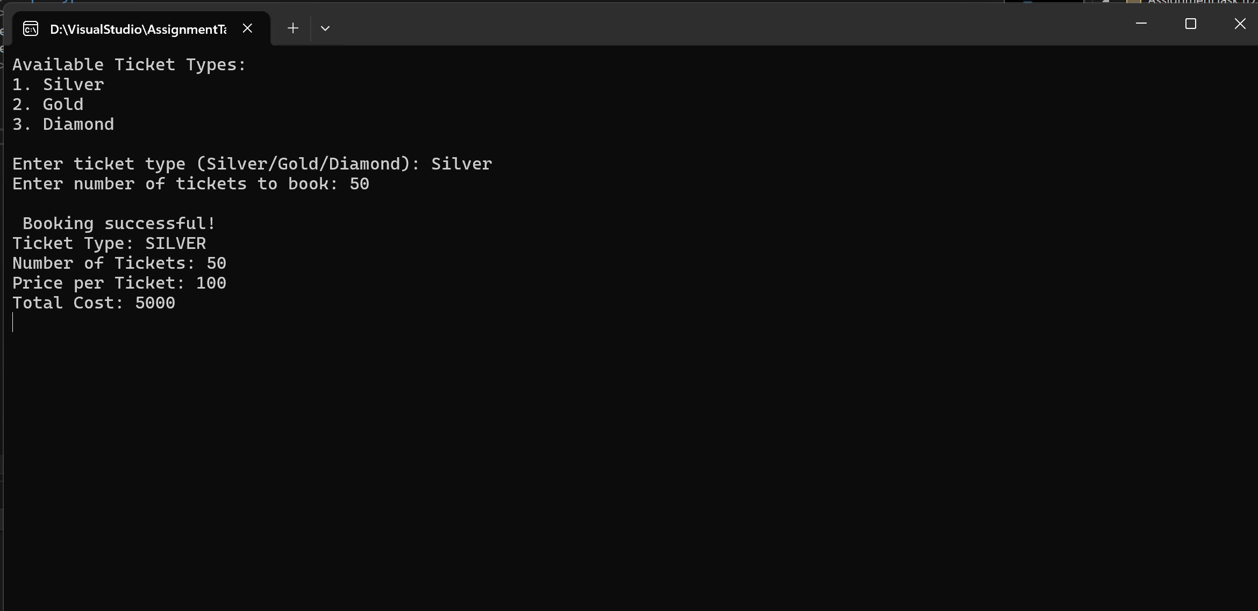

**Task-3 Looping :**

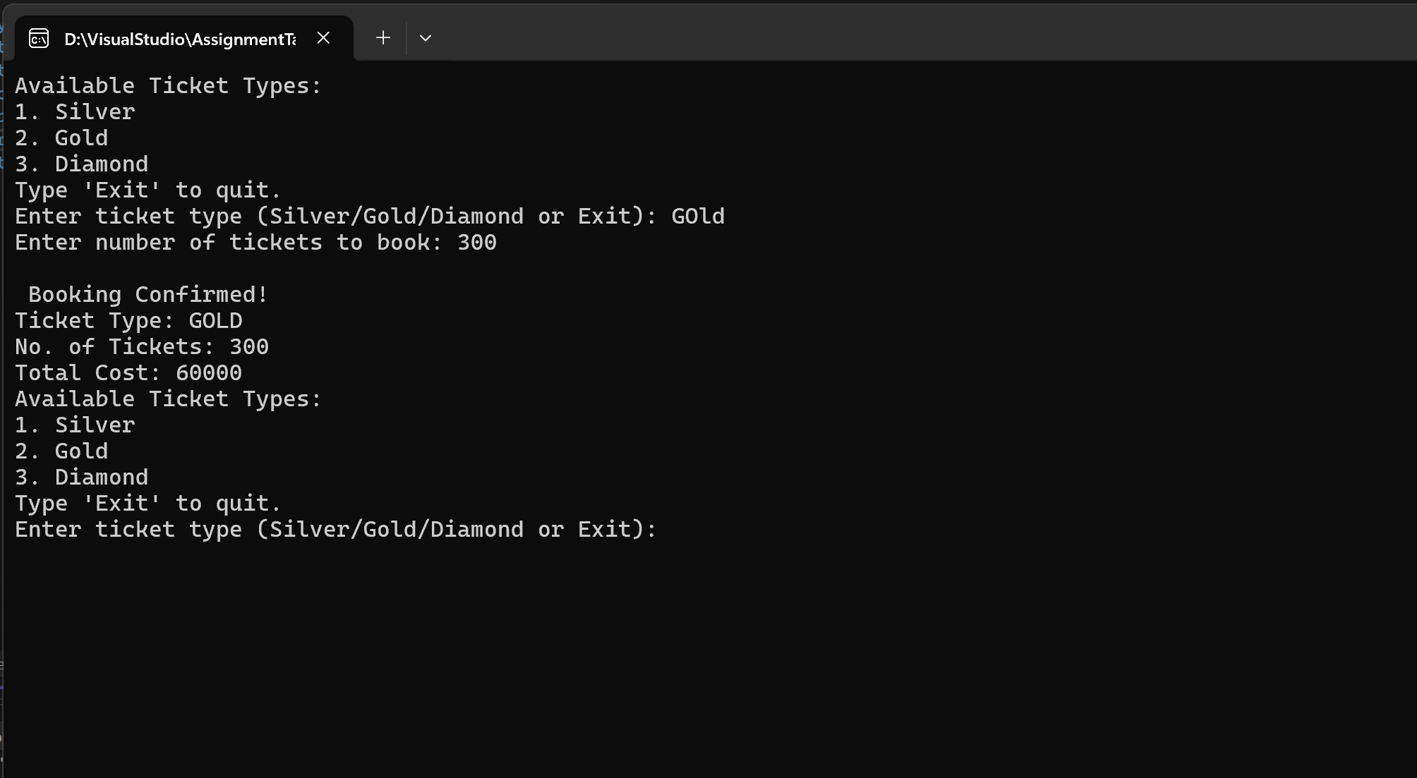

**Task-4 Class and Object:**

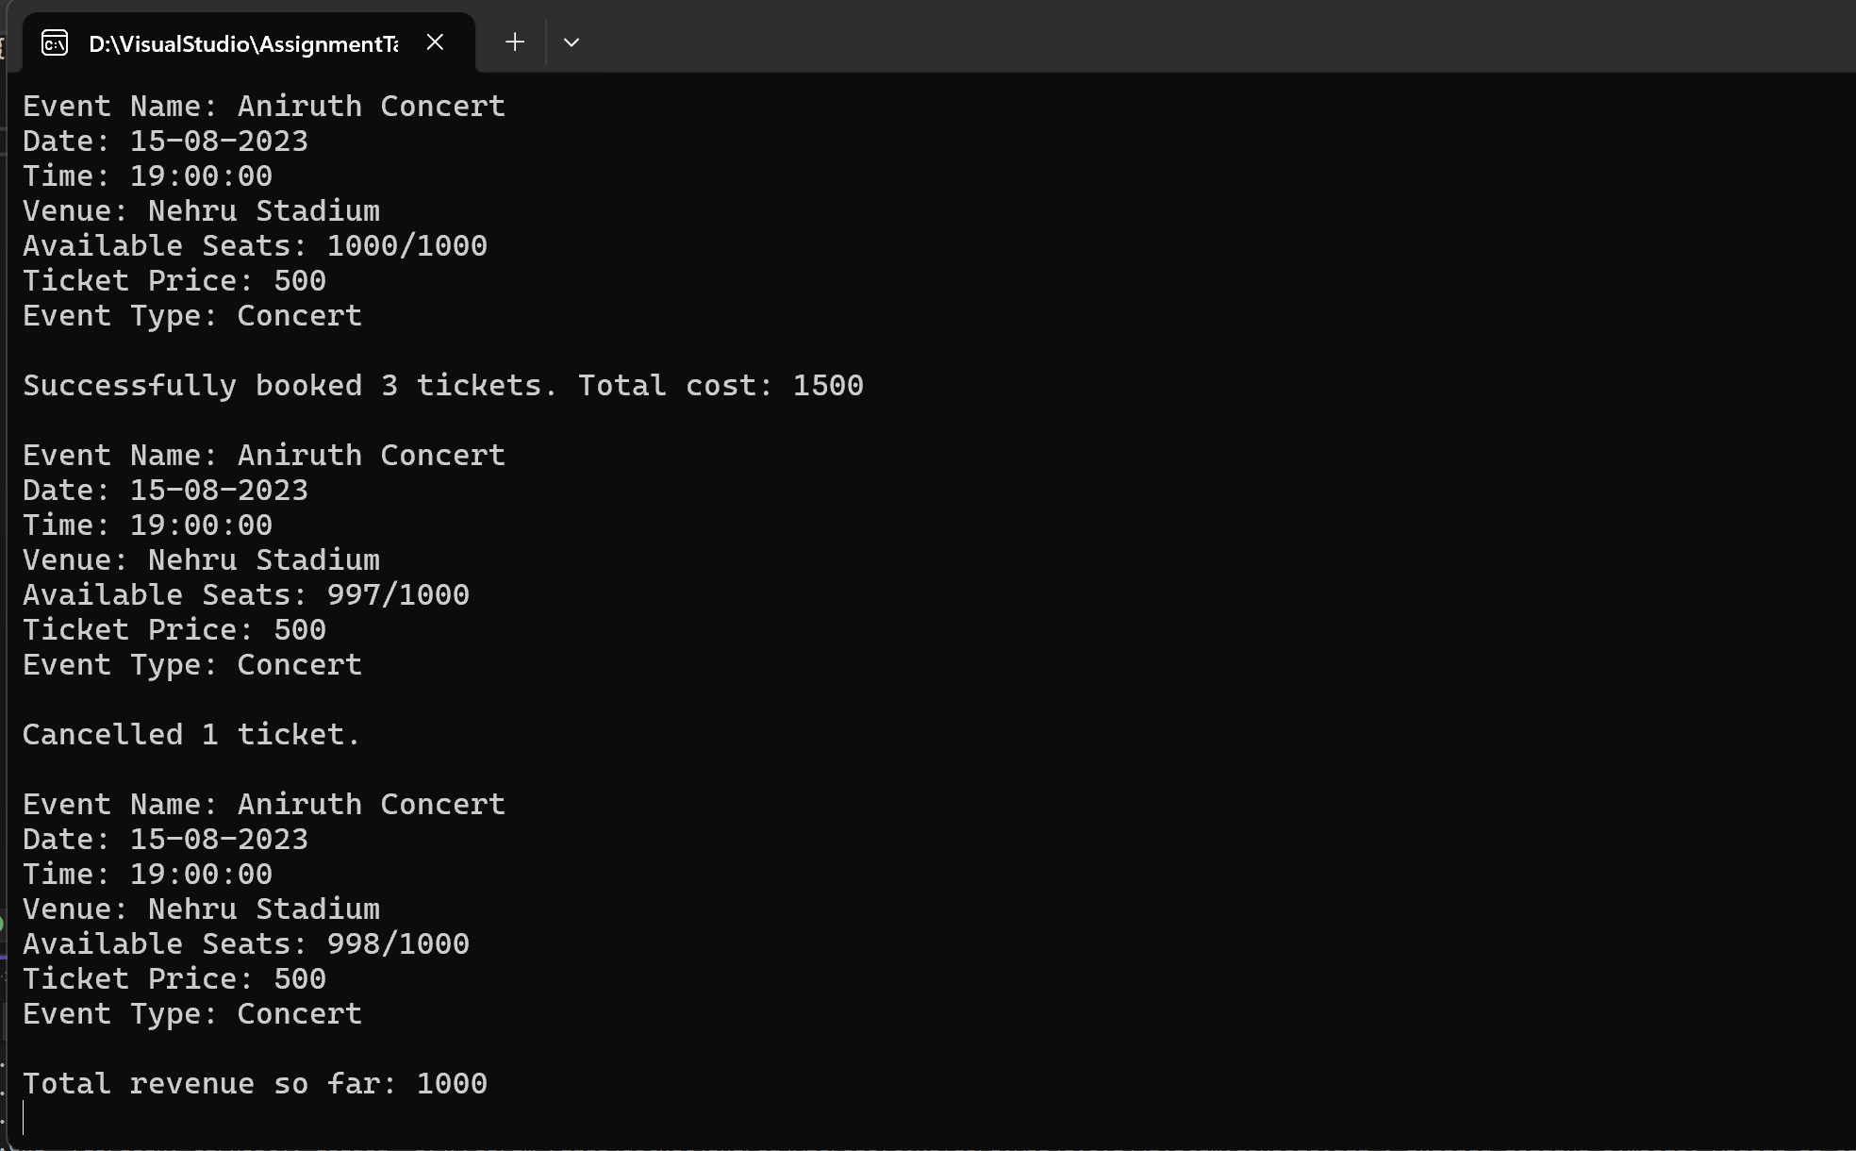

**Task-5 Inheritance and polymorphism:**

**1.View Event Output :**

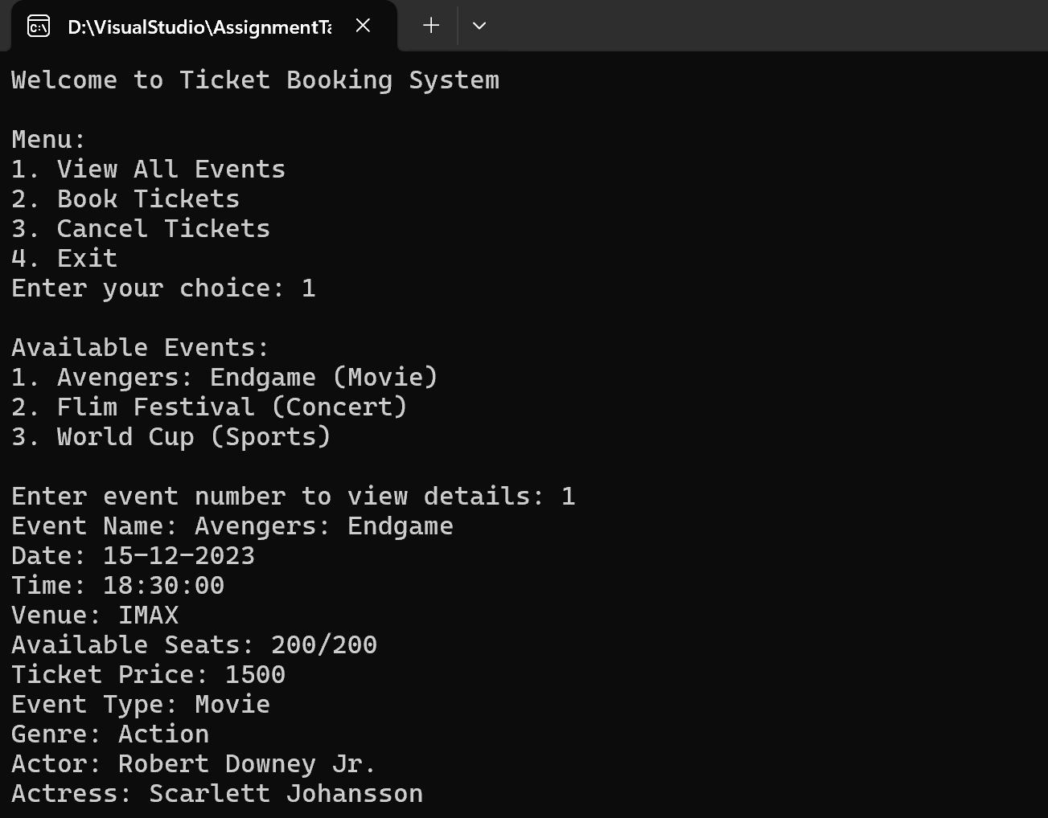

**2.Booking Ticket Output :**

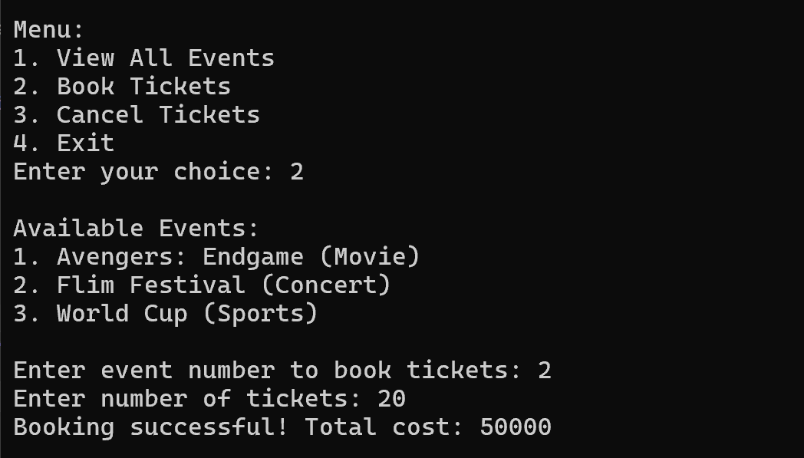

**3.Cancel Ticket Output :**

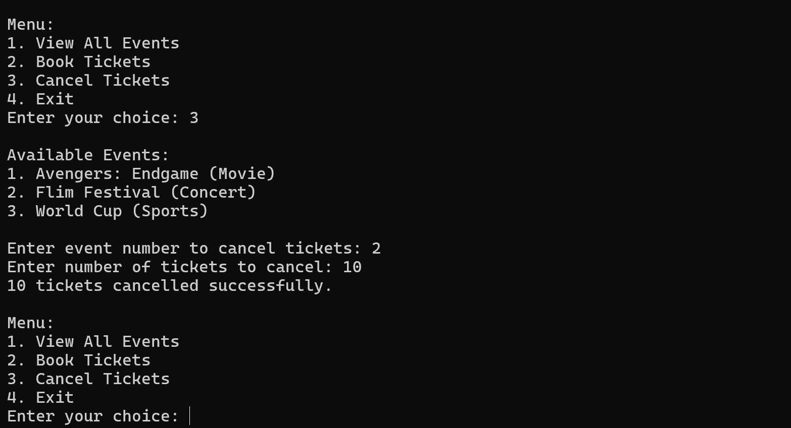

**Task 6 – 11:**

**Avaliable Menu :**

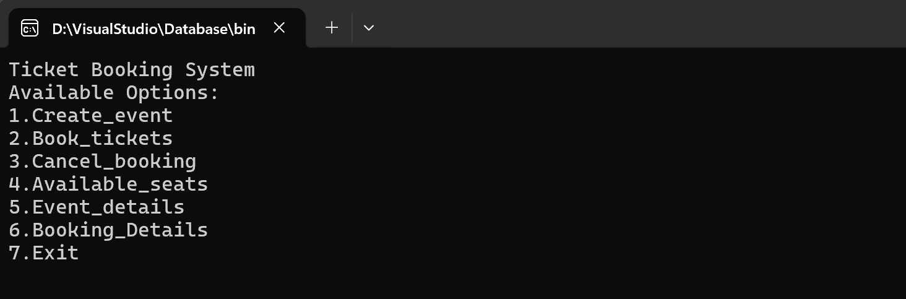

**1.Event Creation :**

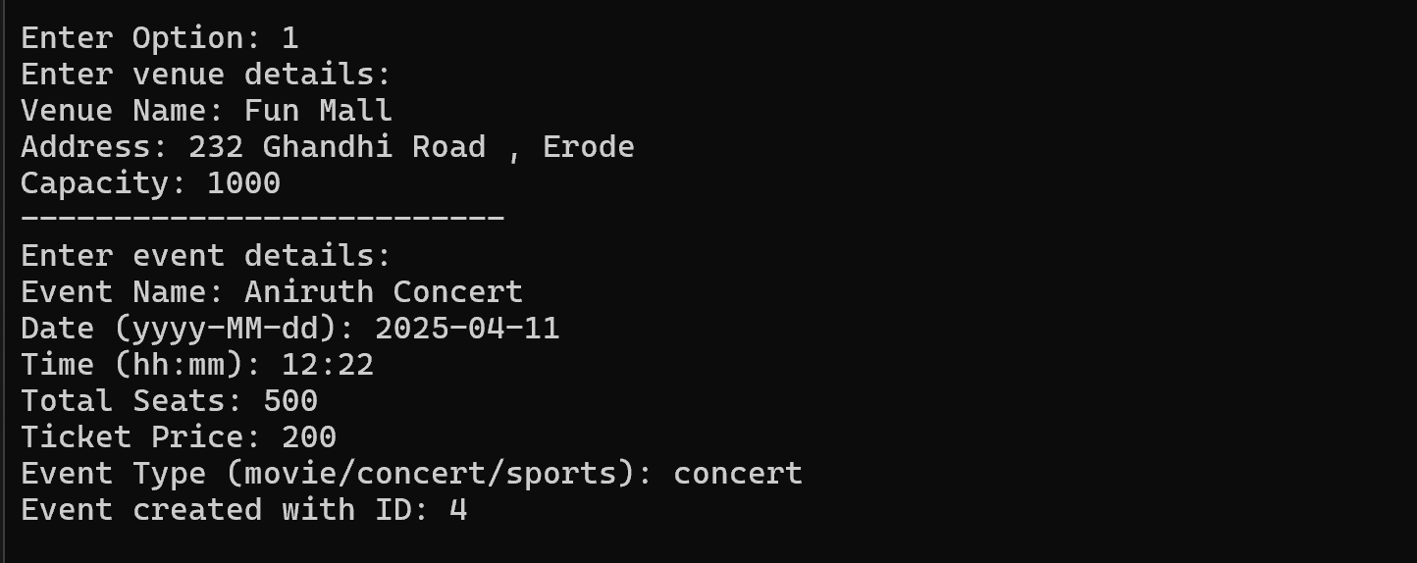

**2.Booking Ticket:**

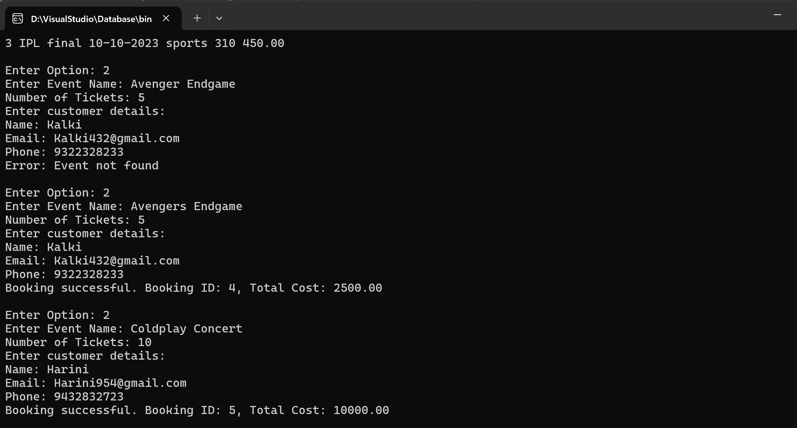

**3.Cancel Booking :**

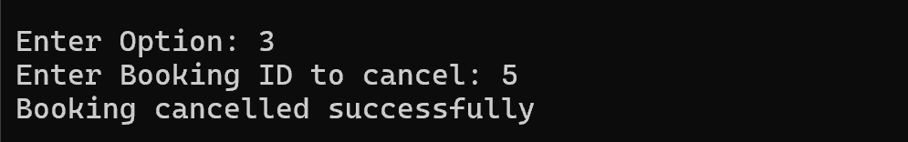

**4. Avaliable Seats:**

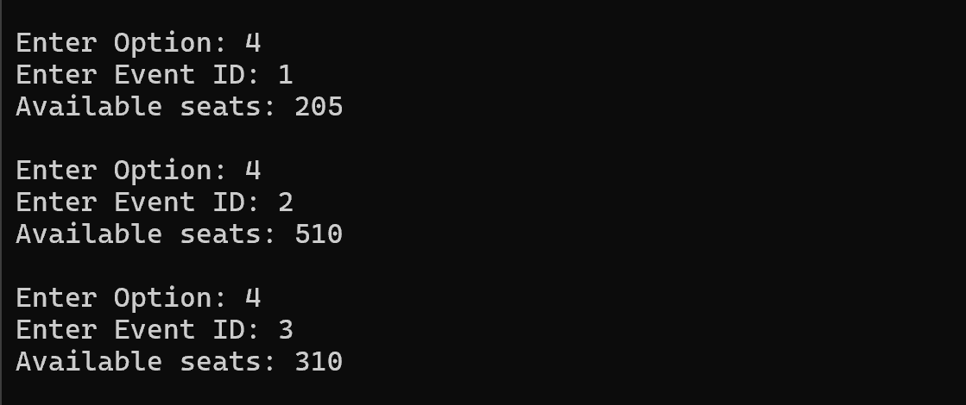

**5.Event Details :**

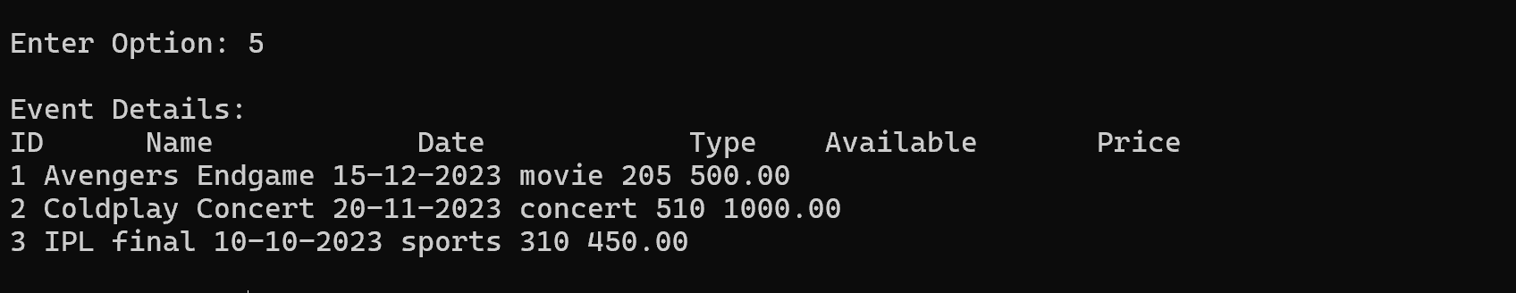

**6.Booking Details :**

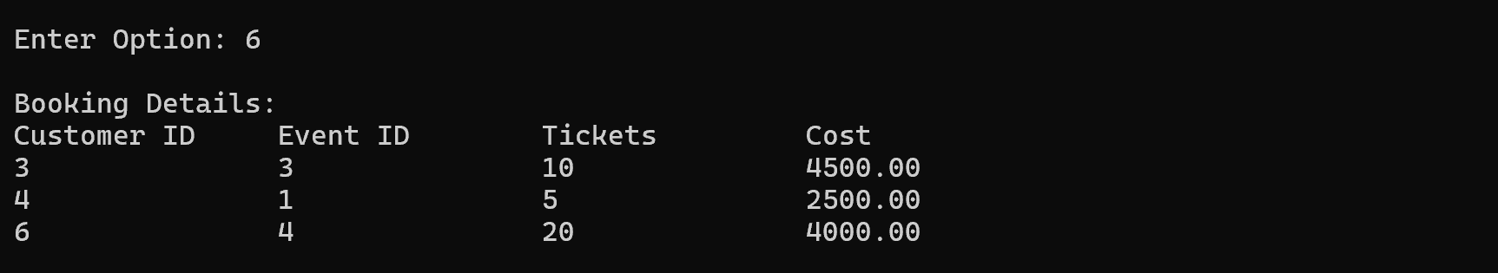

**7. SQL Output :**

